Troubleshooting Guide



**Troubleshoot Sharepoint Issues**

Contents

1. Site Collection admin 3

2. Sharepoint Access issue 4

3. Sharepoint designer/InfoPath issue 6

4. Sharepoint file Upload/Download Issue 6

5. Change the Site Owner or Executive Sponsor for an Existing Site 9

6. To search SharePoint site details in ServiceNow 9

7. SharePoint provisioning/Deactivation/Costing/Backup 10

8. Restore a SharePoint Team Service Request/Sharepoint inaccessible 11

9. SharePoint search issue 11

10. Sharepoint quota increase

11. Sharepoint usage details 13

12. Sharepoint general issues/Links 14

# Site Collection admin

Site collection administrators have full rights to all sites within a site collection. They can add or delete sites/users or change the settings for any site within a site collection. They can view, add, delete, or change all content within those sites as well.

When a request for the Site collection admin of a site is made. There are two ways this can be checked

1. Site Collection Admins of a **Sharepoint site OR MS Teams site (group sites)** can be checked from [MC Portal](https://mcportal.accenture.com/WebTools/TeamSites/). Below is sample when trying to search for SCA of a site:

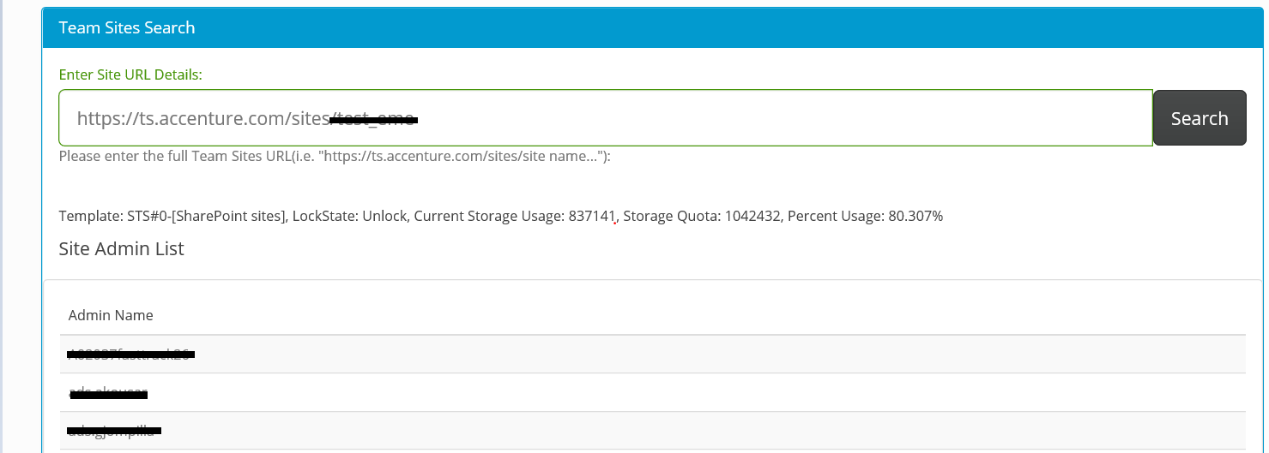

1. Checking via site – user can check the SCA from directly from the site.
   1. Access the site
   2. Click on the settings icon on the top right
   3. Click on Site Settings
   4. Under “Users and Permissions” click Site Collection Administrator, you will find the details.

Note: Use Chrome for quicker experience of [MC Portal](https://mcportal.accenture.com/WebTools/TeamSites/) access

# Sharepoint Access issue

There are multiple reasons for access issue, please find below and their respective resolution that can be done from user’s end:

1. **User has no permission in the site and getting the error below:**

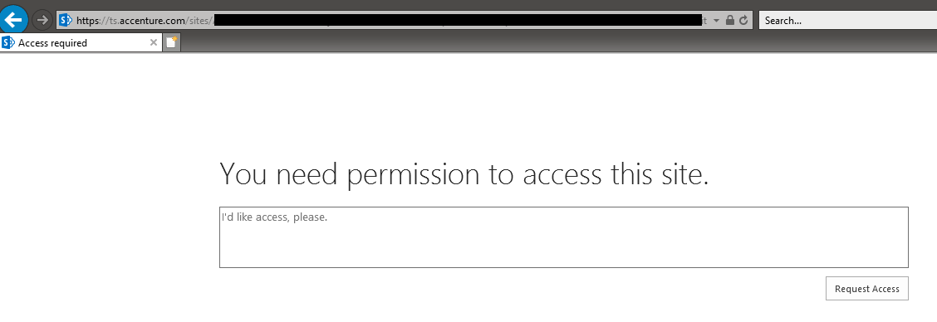

1. User can request access from that page – ask them to put a note in space then click request for access. This will send a notification to the site collection admins (SCA) of the site then they can either accept or deny the request.
2. User can request access by reaching out to the site collection admins (SCA) – please refer to the “SITE COLLECTION ADMIN/ACCESS ISSUE No. 1” on how to check the SCA of the site.
3. User is unable to access the site even though permission is granted.
   1. Reach out to SCA/Full Control user, then request to remove then re-add user’s permission. Steps how to remove/re-add that can be forwarded to the SCA/Full Control user is below:
      1. 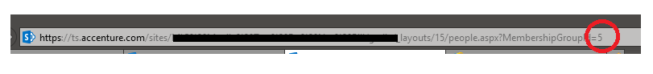Navigate to the People and Groups of the site; Site Settings > Under “Users and Permissions” > People and Groups > Modify the URL in the URL bar
      2. Change the last number in URL to zero (0) then ENTER. It will show all the names that has access to the site. Find user’s name then remove from there.

Note: All the permission of the user in the whole site will be removed.

* + 1. To re-add, navigate to the site; Site Settings > Under “Users and Permissions” > Site Permissions > Grant User’s Permission back

NOTE: Please be mindful of removing and re-adding permissions, if the user has unique permissions all over the sites, make sure that the SCA has noted all the unique permission so they can re-add all after removing.

User can also refer to [Manage Permissions for SharePoint](https://in.accenture.com/teamservices/managing-permissions-and-security-in-sharepoint/manage-permissions-for-a-sharepoint-list-or-library/)

1. After reaching out to SCA and the issue persists – assign the ticket under M&C queue (MSGCOLLAB-O365-OPER) with the following information:
   * 1. EID of the affected user/s
     2. URL of the Access Denied URL – just copy the URL in the URL bar while the user is in the access denied error such as below:



1. User is having the below error message when trying to log into a SharePoint site. The user is an external and trying to access Accenture SP Site (ts.accenture.com). Eg. [User.name@xyz.com](mailto:User.name@xyz.com).

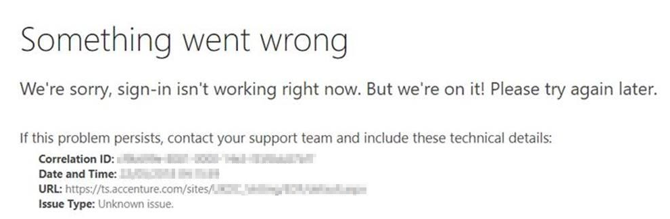

**Solution:**

The external users should have @accenture.com account. Advise them to create an ID at [link](https://directory.accenture.com/myclientid/). ID should have necessary license that is needed to access any SharePoint site.

# Sharepoint designer/InfoPath issue

Users cannot access SharePoint site via SharePoint Designer and InfoPath and having such errors:

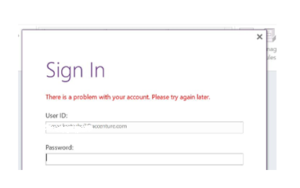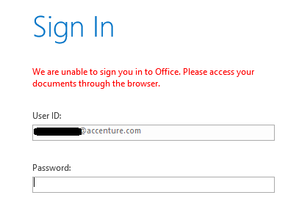

**Follow the steps below:**

1. Uninstall SharePoint Designer and InfoPath (if the user have it)
2. Download InfoPath from <https://www.microsoft.com/en-us/download/details.aspx?id=48734>
3. Download SharePoint designer from <https://www.microsoft.com/en-us/download/details.aspx?id=35491>
4. Install the InfoPath then log in user’s EID.
5. Re-install SharePoint Designer
6. Reboot user’s machine

# Sharepoint file Upload/Download Issue

**Issues in uploading files**

Users are reporting that they cannot upload files in SharePoint and getting the error below:

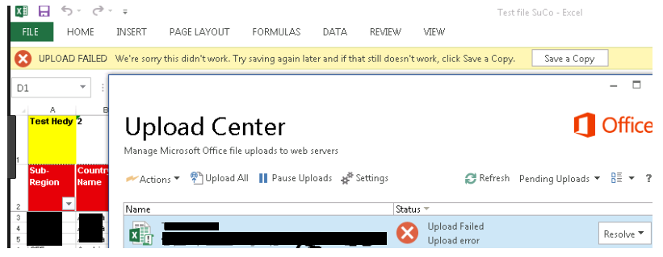

This is **NOT** an issue with SharePoint – this issue is from the Office Upload Center of user’s machine.

Ask the user to check the reasons why the files are failing by accessing the Office Upload Center then resolve it there:

Start Menu > Search for Office Upload Center > Office 2016 Upload Center

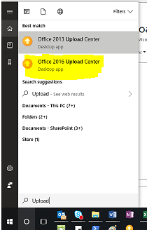

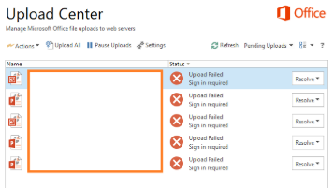

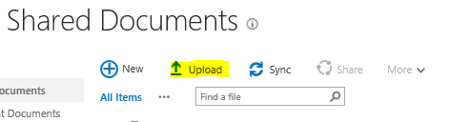If the issue persists, user should upload the file directly from the SharePoint site by using the “Upload” option – this should work just fine:

**Issues in downloading files**

Users are unable to download multiple files – “Download” is grayed out when multiple items are selected.:

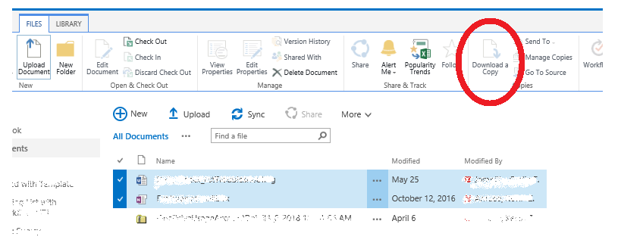

Folders are not downloadable as well – user should open the folder then download each file: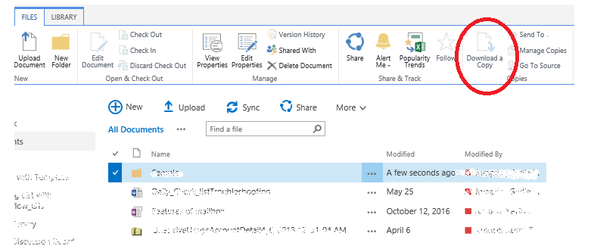

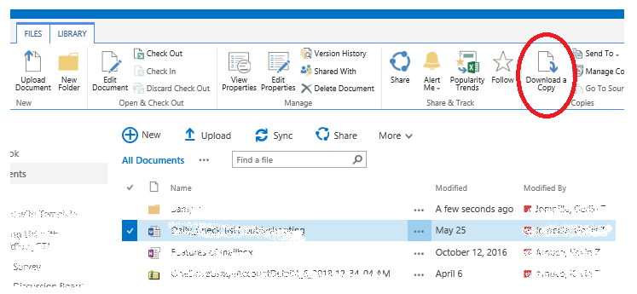Users should download each file.

Or use the “Open with Explorer” to download/copy multiple items:

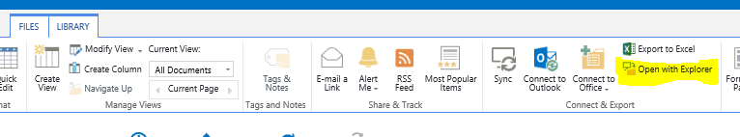

Note: Open with Explorer doesn't work in Windows with Microsoft Edge, Google Chrome, or Mozilla FireFox, or on the Mac platform. It only works with windows explorer.

# Change the Site Owner or Executive Sponsor for an Existing Site

1. Navigate to the [Team Service Request Form](https://accentureinternal.service-now.com/support_portal/?id=iframe_catalog_request&sys_id=0813b9900f6d1600e65a4b9ce1050eeb).
2. Select the Request type "Update Existing Access"
3. Next, using the Site Name field, select your site and the site information (Primary Owner, Secondary Owner and Executive Sponsor names) will load.
4. Enter a new owner or sponsor and any additional information if needed.
5. Click Submit.

NOTE: User must be a Primary Owner, Secondary Owner or Executive Sponsor of the site to complete these steps.

To check the Site collection admin of SharePoint site, please refer section **1. Site Collection admin**

# To search SharePoint site details in ServiceNow

The quickest way to ascertain details about SharePoint site is to ask the requestor for the RITM# that was provided upon creation.

If provided with the RITM#, login to service now and search the RITM on the Requested Items Section (refer the steps below)

1. Login to https://accentureinternal.service-now.com/
2. Click on the magnification /search icon at the right-hand top corner, and search with the RITM number to check the request
3. You can check the owner, executive sponsor, charge code of SharePoint site as below

A screenshot of a cell phone

Description generated with very high confidence

In case the RITM number is not known by the user.

The service desk can search the same by following the steps below

1. Login to <https://accentureinternal.service-now.com/>
2. Under “Filter navigator” (left top corner), click on all application
3. Click on “self-service”
4. Under open Requested items
5. Click on the filter icon, and provide the condition as below,
6. Search the SharePoint site with root name of the site for example as below:

SharePoint site URL: <https://ts.accenture.com/sites/Test_1>

Root name: Test_1

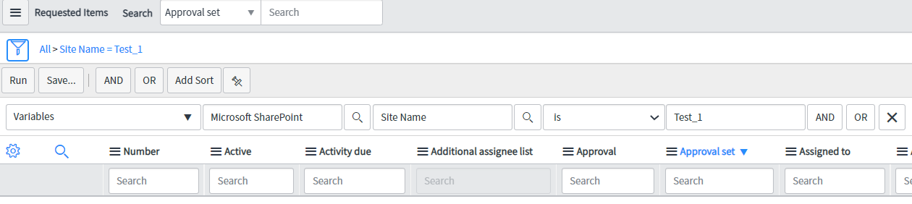

# SharePoint provisioning/Deactivation/Costing/Backup

1. **Sharepoint provisioning/Deactivation/Costing request**
2. Log in to <https://accentureinternal.service-now.com/support_portal/>
3. Click Technology Support
4. Search for “SharePoint Team Services” then click
5. Input necessary details then “Submit”

All issues in provisioning, incidents should be ALL routed to DSRM Team (**SNOW Queue: APPSUP-APP-CIO-DSRM**) as well the inquiry about the SharePoint site deactivation and costing.

When owners receive an email saying *“One or more services you are subscribed to is scheduled to be deactivated due to invalid data. Actions needs to be taken within two weeks”* – ticket should be directed to DSRM Team (**SNOW Queue: APPSUP-APP-CIO-DSRM**) or the reason for deactivation must be corrected.

1. **Sharepoint costing is viewable as below**
2. Log in to <https://accentureinternal.service-now.com/selfservice>
3. Click Technology Support
4. Search for “SharePoint Team Services” , the costing details will be available
5. **SharePoint Back-up/Migration Requests**

All Migration requests should be logged via SNOW and the incident should assign to M&C Team **(SNOW Queue: MSGCOLLAB-O365-OPER**)

# Restore a SharePoint Team Service Request/Sharepoint inaccessible

A Sharepoint site may get into “403 FORBIDDEN” error

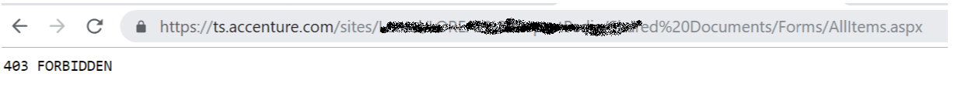

1. Visit: Accenture [**ITServices**](https://accentureinternal.service-now.com/support_portal) site - https://accentureinternal.service-now.com/support_portal
2. Click Tickets on the header bar
3. Click VIEW
4. Look for SharePoint Team Services, Click
5. There is a 'Restore' button at the top of the page, make the changes first before clicking the button
6. Update the Charge Code and Owners if necessary
7. Click ‘Restore’ button on top
8. Restoration takes 12-24hr before being activated
9. If user is experiencing other issues, call the local tech support

NOTE: If it has been more than 30 days since Deactivation, log a new service request

# SharePoint search issue

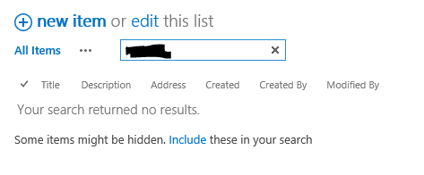User are unable to search in their site, lists and libraries. When trying to search, it is returning zero.

User can manually re-index the list or library from their end – steps are below:

**Re-index a site**

1. On the site, click Settings > Site Settings.
2. Under Search, click Search and offline availability.
3. In the Re-index site section, click Re-index site.
4. A warning appears, click Re-index site again to confirm. The content will be re-indexed during the next scheduled crawl.

Warning: Re-indexing a site can cause a massive load on the search system. Don’t re-index your site unless you’ve made changes that require all items to be re-indexed.

**Re-index a document library or a list**

1. On the site, go to the list or library that you want to re-index.
2. In the ribbon, click the Library tab or the List tab.
3. In the Library ribbon, choose Library Settings

OR

In the List ribbon choose List Settings.

1. On the Settings page, under General Settings, choose Advanced settings.
2. Scroll down to Re-index Document Library or Re-index List, and click the button. The content will be re-indexed during the next scheduled crawl.

NOTE: For the re-index to take effect, user needs to wait at least 24 hours before trying to search again to finish the crawl from Microsoft side.

User can also refer to [Manual Re-indexing](https://support.office.com/en-us/article/manually-request-crawling-and-re-indexing-of-a-site-a-library-or-a-list-9afa977d-39de-4321-b4ca-8c7c7e6d264e).

If the issue persists, please raise a case with M&C team (MSGCOLLAB-O365-OPER).

# Sharepoint quota increase

The default site quota of new created site is now 200GB. Please refer to this [link](https://accentureinternal.service-now.com/support_portal?id=iframe_catalog_request&sys_id=0813b9900f6d1600e65a4b9ce1050eeb).

In some instances when user has consumed the 200GB site quota. The next possible is 400GB but it is subject for approval received from the Sharepoint site owners and M&C Engineering team. This request should be logged via SNOW ticket and should be assigned to M&C Team **(SNOW Queue: MSCOLLAB-O365-OPER).**

The ticket should already have a business justification by answering/acknowledging the following:

Answer the questions 1-3:

1. Why can't you clean-up your site?
2. Why can't you stay below 200GB?
3. Why can't you implement a 2nd site?

Acknowledge the following statements:

1. Do you understand and agree that by increasing the site collection quota over 200GB the duration of an eventual site copy (if requested) would be affected? It could possibly take weeks or maybe month/s to complete a site copy request.
2. Do you understand and agree that there will be a huge cost when you request for a site copy that is over 200GB?

Once approved by M&C Engineering Team, M&C will proceed in increasing the site quota to 400GB.

# Sharepoint usage details

1. You need to have full control to check the site quota usage, If you do not have reach out to the Site collection admins (Details discussed under “Site Collection admin” section)
2. Once on the site, click on the settings gear on the top right  and then click on Site Settings.
3. On the "Site Settings" page, under "Site Collection Administration", click Storage Metrics.

Your site collection storage quota will appear in the top right corner of the "Storage Metrics" page, along with a breakdown of data usage.

**OR**

You may just use the URL https://ts.accenture.com/sites/site name**/_layouts/15/storman.aspx** which implies you will just need toappend “**/_layouts/15/storman.aspx”** to the root site to access information of the storage used.

**OR**

SharePoint Usage can be checked at [SharePoint Team Sites Search Tool](https://mcportal.accenture.com/webtools/teamsites) –

For Eg:

Current storage and storage quota of the site is in Megabyte Units (MB) as shown below:

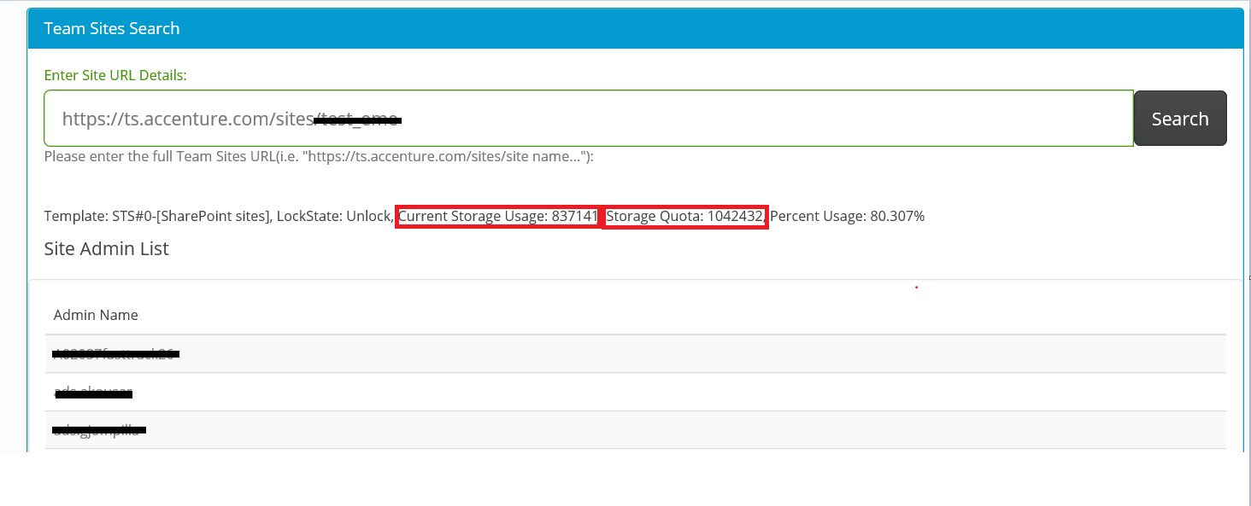

# Sharepoint general issues/Links

There are general issues that users are reporting and for us to start any investigation, there will be important information needed from user’s end which should be already enclosed in the ticket before assigning it to M&C Team **(SNOW Queue: MSCOLLAB-O365-OPER)**

1. URL of the SharePoint site – preferably the exact URL that is having an issue/error
2. Description of the issue, if there is any error:
   1. provide the screenshot of the error – expand the error if needed
   2. exact steps how the user obtain such error, screenshots will be greatly appreciated
   3. sample of users that are having the error
3. Does it work from another machine?
4. What browser and version is being used?
5. When did the problem start?

**Links:** https://in.accenture.com/teamservices